Lucinda Jetty Remediation
Access Methodology Options Assessment
Prepared for Sugar Terminals Limited, attention Tim Coltzau
Stage 1 study deliverable under accepted proposal ED-018-2026-01
Commercial in confidence
Document number | Revision | Date | Status
ED-018-2026-02 | A | 21 August 2026 | Issued for client review

 | Name and role | Signature and date
Prepared by | S Kurien, Consultant, Endura Decommissioning
Reviewed by | J van Iersel, Director, Endura Decommissioning
Approved for issue | J van Iersel, Director, Endura Decommissioning

Revision history
Rev | Date | Description of revision | Prepared | Checked
A | 21 August 2026 | First issue to Sugar Terminals Limited | S Kurien | J van Iersel

Companion model: ED-018-2026-06 Access Options Model Rev A. The cycle, fleet, cost and sensitivity figures in this report are computed there; Appendix C maps each figure to its sheet. Progress is measured throughout in completed, quality closed bents per week. The contractor's claimed output is a payment stage equivalent and is labelled as such wherever it appears; it is not a completed bent rate and is not treated as one.
Scope of this assessment. This report assesses the provision, movement and logistics of access to the works: how crews, plant and containment reach each pilebent and move to the next. The trade works themselves, the welding, blasting, coating and jacket installation, are held at the contractor programme durations, crew make ups and rates throughout, and are not repriced. What this assessment changes is how often a trade crew has a face to work on.

1. Executive summary
This assessment addresses three questions: the production rate required to meet the deadline, whether the current access method can achieve that rate, and the cost of an access method that can meet the deadlines.

Required and achieved delivery rates
Clearing the 227 priority bents within the 2027 and 2028 work seasons requires 4.5 completed bents per week. The contract programme was planned at 2.0 to 2.5 bents per week, which means the plan itself was roughly half the required rate before a single day was lost. The claims record for March to July 2026 shows about 0.36 stage equivalents earned per week, one twelfth of what the deadline requires.

Rate per week, basis stated | Value | Outcome at that rate
Required for the priority scope by end 2028 | 4.5 | October 2028
Contract programme planned rate | 2.0 to 2.5 | 2030 and beyond
Claimed stage equivalents, March to July 2026 | 0.36  (March to July is 21.9 calendar weeks – 7.9 bents (1 March to 31 July, 153 days ÷ 7). So 7.9 ÷ 21.9 = 0.3607, rounded to 0.36 a week) | Beyond 2035 on that arithmetic; payment stage output, not QA closed bents

Limitations of the current method
The current arrangement has not shown a credible pathway to the required rate, because the constraint sits in the access method and not in the crews. The gap arises from the access method and not from the level of effort or resourcing applied. A scaffold bent runs 15 to 16 working days, of which only about half is trade work; the balance is scaffold erection, encapsulation, dismantling and the engineering approval hold, repeated at every bent. To deliver 4.5 bents per week on that cycle would require 14 to 18 simultaneous scaffold fronts. The method is capped near five fronts by the scaffold cycle itself, the single welding and blasting spiders, and the single lane 8 tonne roadway that every erection and strip movement must share. Five scaffold fronts running without interruption deliver 1.3 to 1.7 bents per week, five or more seasons of work. The current arrangement has not shown a credible pathway to the required rate, because the constraint sits in the access method and not in the crews.

The proposed access method
The recommended access system replaces the rebuilt scaffold with a relocating marine platform: scaffold stages built on float pontoons, pushed to each bent by workboat, joined around the piles, and lifted clear of the tide on synchronised electric chain blocks. The access cost is paid once and moved, not paid again at every bent. The trade work on the platform is unchanged.
Two configurations of that system are assessed.

 | Option 1 Base case | Option 2 Optimised
Working arrangement | All work in day shift. Platforms move and trades work in the same six day cycle. | Trades work day and night on the secured platform. Platforms move and all lifting is in daylight only.
Work fronts required | 8 | 5
Stage halves in the water | 16 | 10
Access cost, Class 5, +25% contingency | $17.55M | $15.16M
Access cost per bent | $77,334 | $66,768
Completion at 4.5 to 5.1 bents per week | October 2028 | October 2028

Option 2 is preferred, and not mainly for the cost saving. Its fleet requirement holds at five to six fronts across the full credible range of weather availability, where Option 1 swings between eight and ten fronts on an assumption that cannot be verified until the fleet is on the water. Option 2 also reduces the platform fabrication demand from eighteen stage halves to twelve against five existing platforms, which materially reduces the risk in a March 2027 mobilisation. Night work is carried as an option subject to a noise assessment and regulator engagement, consistent with the position recorded at the kick off session; no marine moves, lifting or man riding occur after dark under either option.

Access cost comparison
The fair comparison is access provision against access provision, with the trade works identical on both sides.

Access provision | Cost | Delivered rate | Completion
Current scaffold method (contract access allowance, to be confirmed) | $9.3M | 0.36 stage equivalents per week | Beyond 2035 on that arithmetic
Marine access, Option 1 | $17.55M | 4.5 to 5.1 per week | October 2028
Marine access, Option 2 | $15.16M | 4.5 to 5.1 per week | October 2028

In summary: about $5.9M of additional access provision, a factor of 1.6, converts a trajectory that does not close the priority scope into a completion in October 2028, with the trade scope, crews and rates unchanged throughout. Cost figures are concept stage screening estimates. They exclude the platform fleet build or hire beyond the five existing platforms, marine insurances, permits, port charges, accommodation and escalation, each identified in Section 9, so the comparison is not yet complete on both sides and an estimate class is not claimed until a controlled basis of estimate is issued at hold point HP8.
Section 9 also identifies an optimisation path, principally the marine base selection and the wet season stand down, under which the access provision converges on the cost of the scaffold access it replaces. The $15.2M is the conservative build before that path is banked.

Recommendation
- Adopt the marine access method as the reference concept, in the Option 2 configuration, subject to the night work assessment at hold point HP5.
- Procure it through a reference concept and performance specification, with a proving campaign of the first bents as the award gate, so the fleet order is placed on a measured cycle instead of an assumed one.
- Instruct the paid trial fortnight and open the approvals pathway now; both sit on the critical path ahead of any packaging decision.

2. Basis of assessment
This assessment is built from primary documents: the contract scope and specification with drawings QSL2501 JPHR G01 to G04, the contractor programme separable portion sheets, the progress claims workbook, the July 2026 inspection reports, the Phase 1 engineering summary, and supplier material, a manned jack up barge quotation, and a recorded discussion with the coating system supplier representative. An independent marine operability review was completed against the same sources and its findings are carried in the operability model.
Two limitations are declare.. First, the equipment basis rests principally on one access supplier; market soundings with comparator suppliers and marine contractors are programmed for September and are a hold point (HP8) before the delivery model is locked. Second, several inputs remain unverified and are flagged where they appear: the tidal datum interpretation, the bathymetry along the alignment, the contract access allowance figure, and the weather availability percentages, which derive from operator judgement pending metocean records.

Proposal output (ED-018-2026-01) | Where it is answered
Information review and constraint envelope | Sections 2, 3 and Appendix B
Options identification and screening | Section 5
Concept development: configuration, relocation, operability, containment, logistics, structural interfaces, cyclone and shipping response | Sections 6 and 7
Multi criteria assessment and sensitivity | Sections 5 and 7
Indicative programme and cost comparison against the current methodology | Sections 4, 8 and 9
Market soundings | Section 12 roadmap, hold point HP8
Recommended methodology and implementation roadmap | Sections 1, 11 and 12
Options workshop | Scheduled late August 2026

3. The site and its constraints
The jetty is about 5.7 kilometres of repeating two pile bents: a welded box headstock about 7.9 metres long and 900 millimetres deep on two raked piles of 850 and 920 millimetres diameter at a 1 in 4 rake. The deck sits at RL 8.000 with a single lane 8 tonne roadway and a sheeted conveyor gallery above. The tidal range is about 3.96 metres from LAT at RL minus 0.300 to HAT at RL 3.660; the datum interpretation is carried as derived pending verification against drawing G01 and the MSQ tidal planes. Cyclone season runs 1 November to 30 April, leaving two 26 week work seasons in 2027 and 2028, or 50.4 available weeks after shipping allowances. The terminal takes 11 to 15 ship calls a year with jetty access held open on short notice. There is no power on the jetty, the surrounding waters are marine park, and the steel is corroded, so any load hung from the structure requires a certified and proof tested load path.
Night work is treated in this assessment as an option to be assessed, not an exclusion; the executed contract itself carried a night work provision, requiring permanent supervision. The kick off session recorded that the current contractor had itself flagged night tides, and identified the applicable night noise limit of background plus 8 dB(A) as the test to be modelled. The regulator position on night work forms part of hold point HP5.
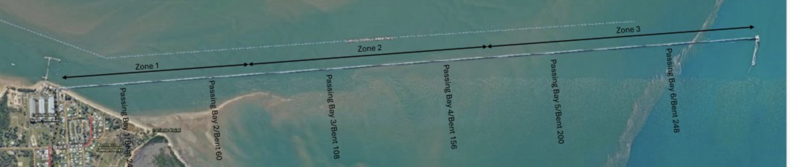
Figure 1. The jetty and its exposure zones. Zone 3 at the wharf head is open water and is worked first; the campaign finishes in the shelter of Zone 1.

4. The current delivery method and its production ceiling
The current sequence at each bent: scaffold is hung from the kerb and the bent fully encapsulated from the roadway; the old wrapping is stripped and the steel washed, inspected and tested; weld repairs are submitted and held for engineering approval with the scaffold standing; welding, blasting and coating follow; pile jackets are fitted in tidal windows; and the scaffold is then dismantled and rebuilt at the next bent.
The productivity constraint of this method is structural. Of a 15 to 16 working day bent, about seven days are trade work; the remainder is access handling, the approval hold and calendar. The access provision is rebuilt at every bent, every bent queues through single welding and blasting spiders, and every erection and strip movement shares the single lane roadway inside its timed windows and 8 tonne limit. The claims record for March to July 2026 shows about 0.36 stage equivalents per week against a planned 2.5. These are payment stage equivalents instead of completed bents; no record establishes the completed, quality closed bent count, and the close out survey at HP7 settles it.
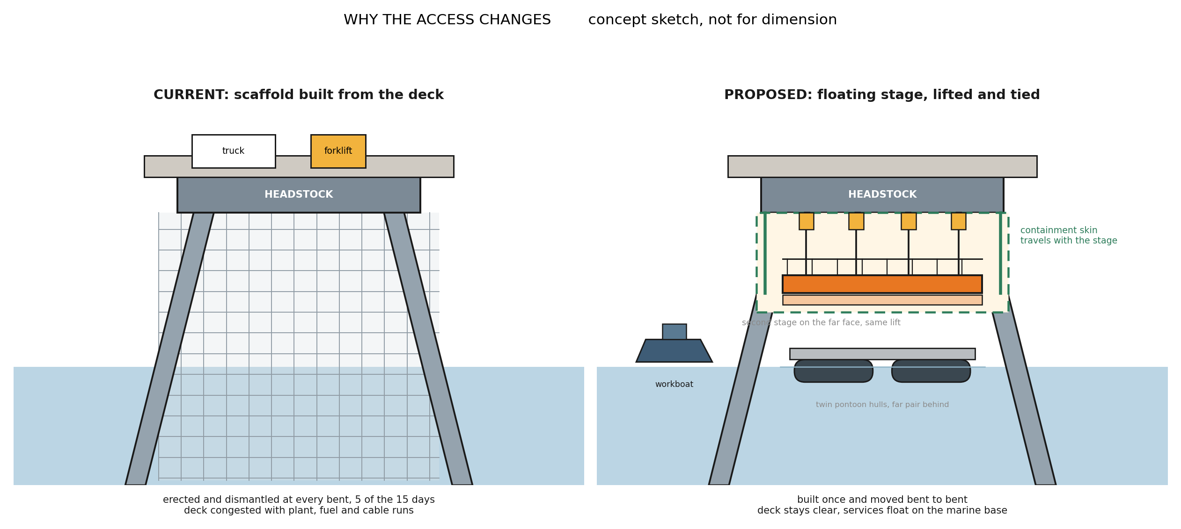
Figure 2. The access change in one picture: scaffold erected and dismantled at every bent, against a stage built once, lifted on chain blocks and moved from bent to bent. Concept sketch, not for dimension.

The ceiling test | Value | Basis
Scaffold fronts needed to reach 4.5 bents per week | 14 to 18 | 15 to 16 day cycle at 70 to 85 percent availability
Fronts the method can sustain | About 5 | Scaffold cycle, single spiders, single lane roadway
What five perfect fronts deliver | 1.3 to 1.7 per week | Five or more seasons of work

The conclusion is a finding about the method, not about any party: the current access arrangement has not shown a credible pathway to the required outcome at the resourcing levels demonstrated, because the constraint that limits it is built into the way access is provided. Retendering the same method transfers the same arithmetic to the next contractor.

Continuation of the current method
At the claimed rate the remaining 227 bents represent about 630 weeks of work, a completion beyond 2035. At the best claimed months, about 0.7 per week, completion falls around 2032.

5. Options identified and screened
Six candidate methods were screened against the criteria that decide this job: production rate, tide independence, containment, roadway impact, structural loading, cyclone response, safety in design, approvals exposure, and reuse. Scores are one to five, assessed by this office; the full matrix with scoring notes is held in the project record.

Method | Screening outcome | Disposition
Scaffold, current | Meets containment; pays the access cost at every bent; capped near five fronts | Retained as baseline
Jack up barge as roving workfront | About four working hours per relocation after jacking cycles; one location serves about two bents; draft and seabed unproven | Rejected as workfront; retained as static marine base option
Floating modular pontoon spread | Tide following and relocatable; sea state limited for fine work over open water | Carried into the recommended system as the flotation element
Floating winched stages | Relocatable, tide independent once lifted, containment on the stage, reduced roadway demand | Recommended for typical bents
Suspended fixed pods | Strong operability; less relocatable along 5.7 km; higher fabrication content | Reserve configuration
Marine rope access | No encapsulated blasting possible | Rejected for headstock works; retained for pile and jacket support tasks

No single method covers every bent family. The recommendation is therefore a hybrid: the floating winched stage system for the roughly 212 typical bents, conventional or re oriented access for the 13 anchor bents and 10 passing bay variants decided plate by plate against the drawings, bent specific methods for the 2 special bents, and the gallery wrapping running as a topside stream inside conveyor outages. Anchor and bracing bents carry materially more intertidal work than typical bents and are carried in the programme at a family multiplier pending the STL bent register.

6. The selected access system
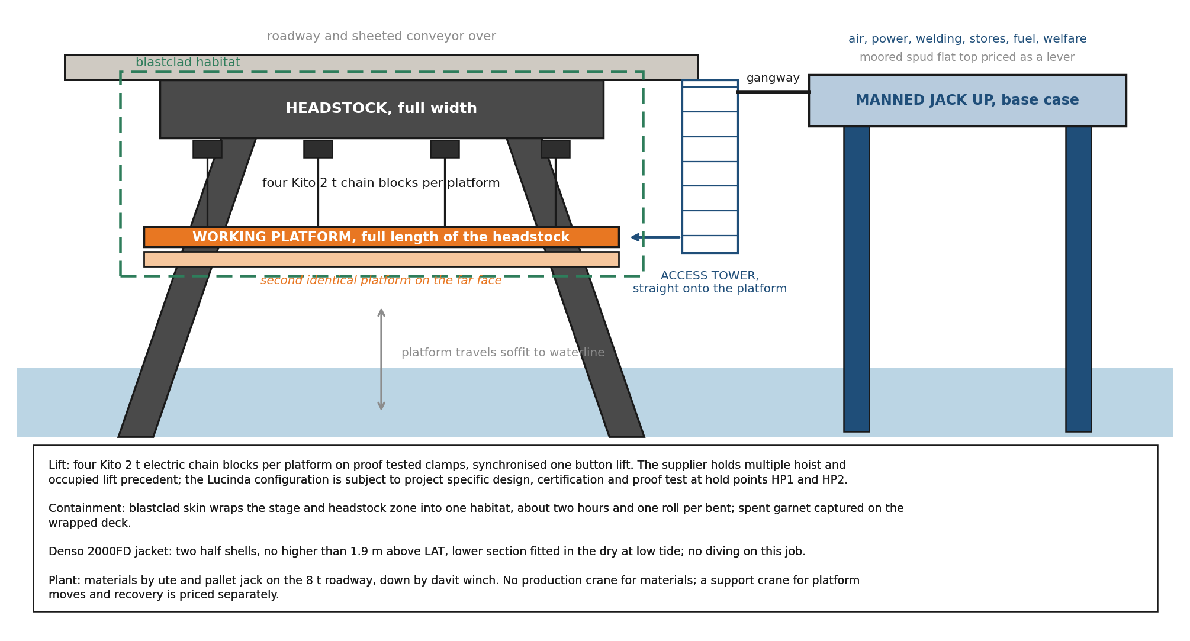
Figure 3. One work front: the floating stages, the chain block lifting system, the containment skin, the jacket band and the materials path.
A front is a scaffold stage built in two halves on 650 litre float pontoons, each pontoon carrying 600 kilograms. A workboat pushes the halves to the bent, a crew of three scaffolders joins them around the piles, and the stage lifts clear of the tidal zone on four two tonne electric chain blocks running through a control panel to a wireless pendant. The blocks jog individually to take tension, then lift synchronised as a multiple hoisting operation under the Australian standard; the supplier has had the system third party certified for man riding on recent projects. At height the stage transfers onto positive ties, the blocks leapfrog to the next bent, and crews step on from the access tower. Crews are off the stage for every lift, and a dedicated rescue craft is on the water whenever crews work over it. Clamps are installed and proof tested one bent ahead by a rigging crew.
Containment wraps the stage itself: sheeting over the stage and the headstock zone turns the work face into one floating habitat, about two hours and one roll per bent, with spent media landing on the wrapped deck for recovery and, where its condition allows, recycling. The pile jacket is supplied as two half shells closed around the pile, fitted within the band the coating specification defines, with the lower section placed in the dry at low tide. There is no diving.
The campaign spread behind the fronts is one marine production system: the manned jack up as its base, the floating stages, the workboat and the support crane. The jack up is the base case because it is the productivity engine of the fleet. It hosts compressed air and welding power reticulated to the fronts, breathing air, coating stores held at temperature, a bunded fuel cell drawn down weekly, water and waste handling, equipment and spares storage, and crib, washrooms and drying space at deck level. Crews transfer by gangway and access tower and remain on the water through the shift, so meal and amenity breaks no longer cost a drive along the wharf. Every one of those services would otherwise queue on the single lane 8 tonne roadway; hosting them afloat removes that traffic from the wharf, protects terminal operations, and returns the saved movements to trade time. The moored spud flat top is retained as a priced lever with its service continuity risk stated: when weather prevents boarding a spud, the fronts lose air, power and welding with it. The support crane, priced separately at the card low band, covers platform moves and recovery where floating conditions do not allow a water move. The workboat runs the moves, the lifts and the crew transfers, in daylight only.
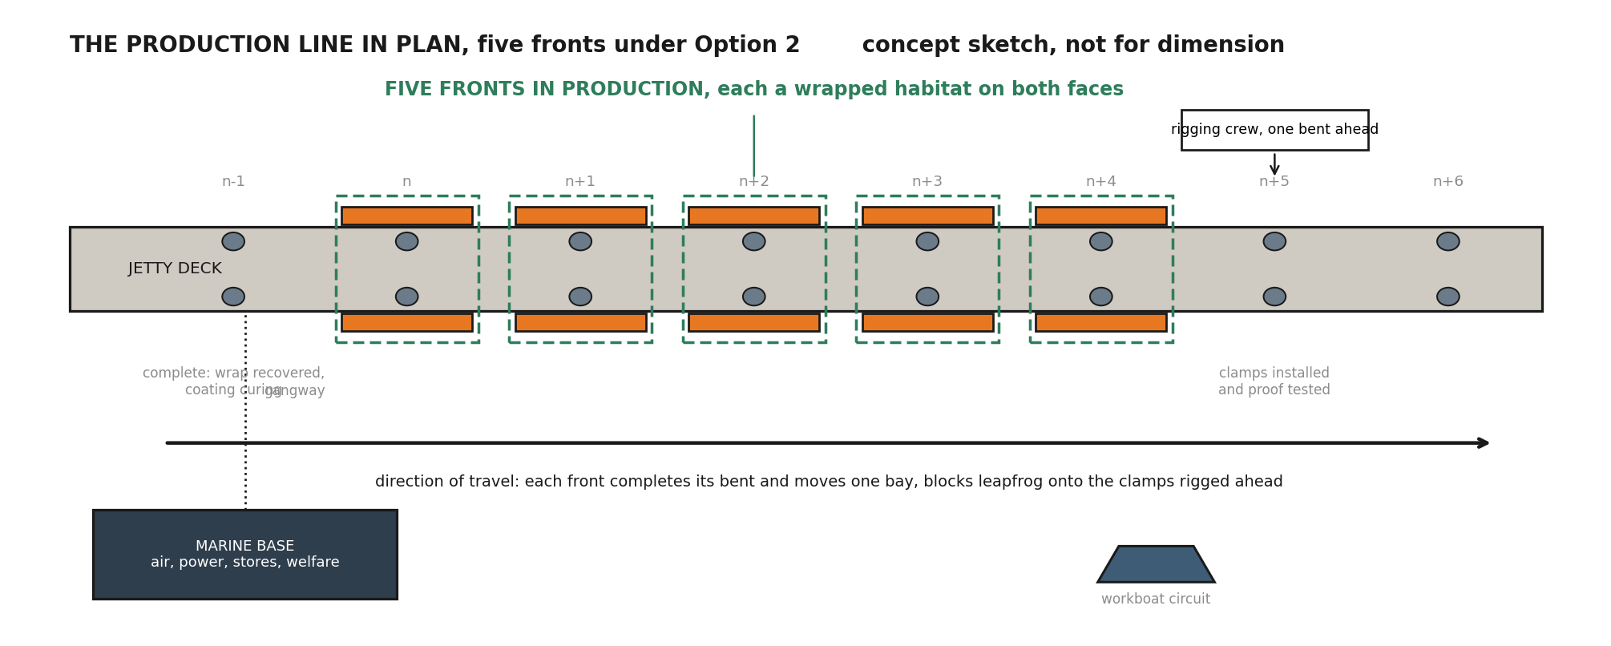
Figure 4. The production line in plan: five fronts in work, the rigging crew one bent ahead, the completed bent curing behind. Concept sketch, not for dimension.
The equipment basis rests on the access supplier's rate card, fabrication drawings and certification evidence, with the supplier holding five pontoon platforms today across three ports. Whether an existing platform constitutes a front or a stage half is to be confirmed with the supplier; the balance of the fleet is a build or hire item that is priced at hold point, and its fabrication lead time sits on the critical path ahead of a March 2027 mobilisation. Supplier names are held in the project record and released on request.

7. Two configurations: the base case and the optimised case
Both options use the identical access system, the identical trade content and the identical rates. They differ only in when the trades work.

Option 1, base case: day shift only
All activity runs in a six day, single shift week. The platform moves, lifts and trade work share the same daylight calendar. With the repair library agreed the cycle is nine working shifts per bent; the operability model derates moves at the floating plant availability and trade work at the fixed platform availability, giving an effective cycle of about 10.3 days and 0.58 bents per week per front. Meeting 4.5 per week requires eight fronts at the reported availabilities, and nine at the mid case.

Option 2, optimised: trades work day and night, platforms move by day
Every marine activity, the moves, the lifting, the man riding transfers, stays in daylight. What changes is that once the platform is lifted, transferred onto positive ties and secured, it is no longer marine plant; it is a fixed suspended work platform accessed from the jetty deck. On that platform the welding, blasting, coating and wrapping continue through a night shift under lighting inside the encapsulated habitat. The seven trade shifts per bent are worked in about three and a half calendar days instead of seven. The effective cycle falls to about 6.4 days, each front delivers 0.94 bents per week, and the fleet requirement falls to five fronts at the reported availabilities, six at the mid case, ten stage halves and about 59 heads across both shifts.
Option 2 requires: a night rescue and medevac capability over water, carried in the cost as a dedicated night standby crew; a noise assessment against the background plus 8 dB(A) night limit, for which the enclosed habitat is the principal control; a light spill assessment against marine park conditions; and coating supplier confirmation of night application. These form part of hold points HP2 and HP5. No marine moves, no lifting operations and no man riding occur after dark.
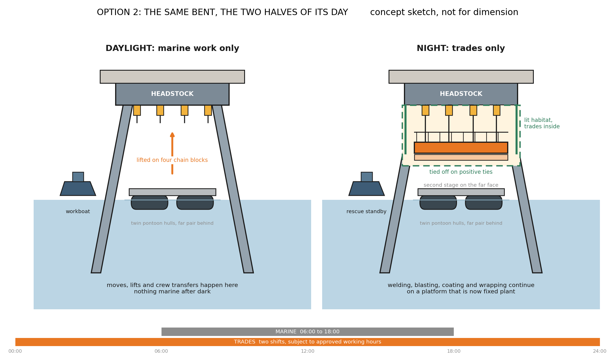
Figure 5. Option 2 in one bent: marine operations in daylight, trades continuing at night on a platform tied off as fixed plant. Concept sketch, not for dimension.

Basis for preferring Option 2
The weather availability of floating plant on this coast is the least verifiable assumption in this assessment; operator judgement puts it between 60 and 80 percent across the season, and metocean confirmation is a hold point. The decisive property of Option 2 is that its fleet requirement is insensitive to that assumption, because compressing the trade duration halves the weather exposure of the longest part of the cycle.

Availability scenario | Option 1 fronts | Option 2 fronts
Pessimistic: floating 60%, fixed 80% | 10 | 6
Mid: floating 70%, fixed 85% | 9 | 6
Optimistic: floating 80%, fixed 90% | 8 | 5
Night crews 80% as productive | not applicable | 6
Marine moves take 3 days, not 2 | 10 | 7
Repair library not agreed | 11 | 8
Scope 257 bents (native programme extraction) | 10 | 7

Option 1 swings between eight and ten fronts on an assumption that cannot be verified before the fleet is ordered.
Option 2 holds at six across the entire credible range, and only reaches nine when the pessimistic weather case and the loss of the repair library are assumed together, which is where Option 1 starts.

The repair library
In both options, three days of every bent cycle is an engineering approval hold. The contract carries a mechanism for pre approved standard repairs; agreeing a repair library with the Superintendent under that mechanism removes the hold from every typical bent. It is the largest single productivity decision available to STL. Until the mechanism is confirmed in the contract text and tested with the Superintendent, this assessment carries the cycle without the library as the conservative case and states both.

Effect on the trade contractor
Because the trade content is unchanged, every gain in this assessment comes from utilisation: trade crews move stage to stage instead of standing while scaffold is rebuilt, and their standing time falls accordingly. That gain accrues to whoever performs the trade works and is deliberately not counted in the access cost case made here.

8. Programme
The campaign calendar: a fortnight to one month proving trial in late 2026 on the supplier's five existing platforms, two hours from site, the lowest cost assurance available, updating costs, sensitivities and the schedule before the season; then mobilisation, assembly and proof loading through March and April 2027; season one from May to October 2027 working Zone 3 into Zone 2; wet season lay up with the fleet on care and maintenance; season two from May 2028 finishing in the shelter of Zone 1; demobilisation and records to close. At the modelled rates both options complete the priority scope on 9 October 2028, about 22 calendar days before the 1 November cyclone closure and about 82 days before the administrative end 2028 date. The season calculation is carried in the companion model on the reported fronts, cycle and calendar. A dated, bent by bent programme with approvals, fabrication, outage and ship call blocks is a hold point deliverable before the fleet order, and the finish above is a modelled outcome, not a programmed date.
Three programme risks outrank the weather. The platform fabrication lead time and the marine park approvals pathway both sit ahead of mobilisation and neither is yet on a programme; and the priority scope quantity itself spans 227 to 257 depending on the register extract requested in Section 11. At 257 bents Option 1 has no float and Option 2 retains about seven weeks.
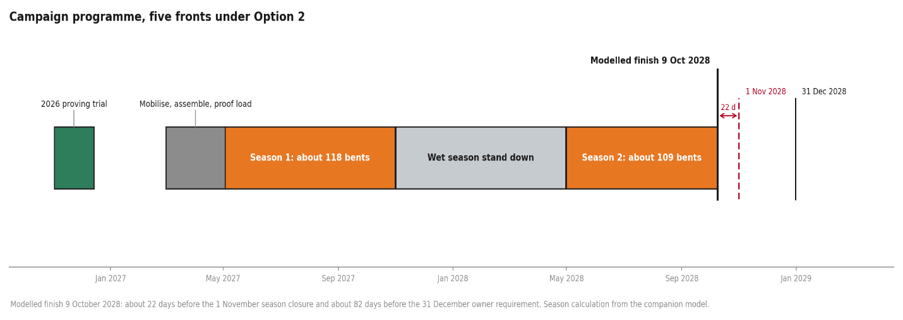
Figure 6. The campaign at five fronts under Option 2: about 118 bents in season one, about 109 in season two, modelled finish 9 October 2028 (season calculation in the companion model).

9. Access cost
The costs below are the access provision only, at concept stage screening accuracy with 25 percent contingency, in August 2026 dollars, before the exclusions listed. They exclude, and Section 11 requests the inputs to price: the platform fleet build or hire beyond the five existing platforms, marine hull and protection and indemnity insurances, marine park and maritime permits, port charges, campaign accommodation, and escalation across the campaign. Trade labour, trade materials and trade consumables are excluded by scope definition and are unchanged from the current arrangements.

Access cost build | Option 1, 8 fronts | Option 2, 5 fronts
Access kit: winches, pontoons, modules | $2.23M | $1.43M
Marine base, operating | $3.40M | $3.38M
Access labour, fleet crew over the campaign | $5.93M | $4.83M
Fixed lines: certification, mobilisation, standby, trial bent, demobilisation | $2.48M | $2.48M
Contingency at 25 percent | $3.51M | $3.03M
Access total | $17.55M | $15.16M
Per bent | $77,334 | $66,768

The marine base is the largest single line and carries the largest single uncertainty: the quoted manned jack up rate and an earlier indicative monthly figure differ materially, and a moored spud flat top alternative is expected to price below both. Reconciling the marine base rate in writing is an action ahead of the workshop, and the operability review's conclusion that the jack up serves best as a static logistics base instead of a roving platform is adopted here.
Set against the current arrangements: the contract access allowance is understood to be about $9.3M for the full scope, subject to confirmation from the contract schedule of rates. The comparison in Section 1 follows: about 1.6 times the access provision, for the difference between a completion beyond 2035 and a completion in October 2028.

Cost optimisation path
The $15.2M is a conservative build, and most of the margin above the current access allowance sits in three lines, each with a live verification already in motion. None of the levers below is claimed in the reported figure; each is banked only when its verification lands.

Lever | Effect | What must be true
Marine base: moored spud flat top in place of the quoted manned jack up | up to $3.5M | Written spud quotation at or near $3,000 per day carrying the same services; the method already treats the base as static logistics, not a workfront
Wet season: off-hire and shore lay up in place of half-rate standby | about $1.4M | Off-hire and remobilisation terms agreed; season two availability secured, or the kit purchased outright
Kit ownership in place of hire | kills the standby line; residual value retained | Fleet build price below about $320,000 per front, the hire-plus standby breakeven; fabrication drawings already exist
Night rescue reclassification | up to $1.2M, carried as upside only | Safety case accepts the lifted, tied and enclosed platform as a fixed workplace with land-based emergency response; regulator concurrence
Contingency step down at award | about $1.2M | Class 5 to Class 4 as quoted rates replace estimates

Package | Access total | Against the $9.3M allowance
Reported base, Option 2 | $15.16M | +$5.9M
Credible: spud base plus wet season off-hire | $10.78M | +$1.5M
Stretch: plus night rescue reclassification | $9.44M | +$0.1M
Stretch at Class 4 contingency | $9.44M | +$0.1M

10. Hold points
Every recommendation in this report sits behind these gates. If any one fails, the framework stands, because the tender then answers it; but none should be assumed closed.

Ref | What must be proven | Cleared by
HP1 | Hanging point capacity at the deck edge on corroded members | Concept design by a registered professional engineer, plus independent check
HP2 | Containment, extraction, noise and night lighting performance in the field | Trial bent under the proving campaign
HP3 | Surface preparation and coating compatibility, including waste classification of the existing system | Written coating supplier position and first batch waste test
HP4 | Seabed and bathymetry along the alignment | Survey data from STL, or an early commissioned sweep
HP5 | Regulator position on marine plant, anchoring and night work, including noise and light spill | Marine park, maritime safety and port authority engagement, with a vessel biosecurity plan
HP6 | Real weather and tide downtime, split between floating and fixed regimes | Operability model built on metocean records, with sensitivity
HP7 | Condition, preservation and true completion status of part complete bents | Close out survey before the restart sequence is set
HP8 | Market appetite and capability beyond the single supplier basis of this report | Market soundings before the delivery model is locked

11. Decisions requested of STL
- The repair library principle, with the Superintendent and the reviewing engineer, including confirmation of the contract mechanism.
- The position on night work as an option to be assessed under HP5, consistent with the kick off record.
- Chart depths along the alignment and the declared berth depth, for the marine base selection.
- Instruction of the paid trial fortnight, which calibrates every number in this report on real bents.

12. Delivery model and implementation roadmap
This section answers the question that follows the method call: having chosen an access method, how does STL buy it, and what must happen between the decision gate and the first bent of the 2027 season.

12.1 Scope separation of access and trade works
Because this assessment separates the access provision from the trade works, the access system can be procured as a facility in its own right and made available to whoever performs the trade works. Three packaging routes follow.

Packaging route | What it means | Where it fits
A. Instructed change within the existing arrangements | The access method is changed under the contract already in place, using its own change mechanism. Trade scope, rates and parties untouched. | Fastest to the 2027 season. Whether the existing arrangements accommodate a change of this size is a matter for STL and its advisers.
B. Separate access package, principal supplied | STL procures the access system as a standalone package and makes the platform available to the trade works. Access measured on platform availability; trade measured on completed bents. | Follows directly from the scope separation. Puts the access risk with a specialist. Requires a clean interface schedule.
C. Consolidated package | A single package covering access and trade works for the remaining scope. | Simplest interface, widest market test, longest lead time to the field.

12.2 Evaluation framework

Criterion | Weight | What is being tested
Production rate and operability | 40 | Demonstrated bents per week, the operability model behind it, and the evidence for the availability assumed
Safety, environment and containment | 25 | Encapsulation and media capture, work over water, lifting and man riding, marine park obligations, cyclone response
Plant, people and marine capability | 20 | Fleet held or firmly committed, fabrication lead time, crewing depth, marine tickets and vessels
Price | 15 | Weighted last deliberately: the access provision is a small share of the outcome, and the cost of a slow method is measured in seasons

Weights are indicative and to be agreed with STL. Mandatory tender content: a production build up bent by bent with the availability evidence; a tide and weather operability model distinguishing floating from fixed regimes; the containment method and waste classification assumed; the cyclone demobilisation plan with trigger and duration; a structural loading report with independent check; and the shift pattern proposed, with a noise model where night work is offered.

12.3 Endura's role
Under the recommended model Endura builds the evaluation framework, completes the market soundings, prepares the performance specification against the reference concept, and scores bids alongside STL. Endura is independent of the equipment suppliers and contractors assessed and holds no interest in the outcome of any tender. Endura's advice under this engagement relates to methodology, programme and procurement; STL retains its own legal and contractual advisers in respect of its existing contractual arrangements, and nothing in this report is advice on them.

Client review and acceptance
This deliverable is issued to Sugar Terminals Limited for review under engagement ED-018-2026-01. Acceptance below records that STL has reviewed this revision and accepts it as the basis for the decisions described in it. Acceptance does not transfer design duty for the reference concept, which remains subject to the hold points in Section 10.
Sugar Terminals Limited | Name and position | Signature and date
Reviewed by
Accepted by
Comments may be returned in lieu of acceptance, in which case a revised issue follows under the revision history above.

Appendix A. The arithmetic

Required rate: 227 bents over 50.4 available weeks, 4.5 per week. Current method: 15 to 16 day cycle, about 5 sustainable fronts, 1.3 to 1.7 per week ceiling. Marine cycle: 7 trade shifts plus 2 move shifts, plus 3 hold shifts where the repair library is not agreed. Option 1 effective cycle: 2 moves at 0.80 floating availability plus 7 trade days at 0.90 fixed availability, 2.50 plus 7.78, about 10.3 days; 6 working days over 10.3 gives 0.58 per front; 4.5 over 0.58 gives 8 fronts. Option 2: trade shifts worked at 2 per calendar day, effective cycle 2.50 plus 3.89, about 6.4 days; 6 over 6.4 gives 0.94 per front; 4.5 over 0.94 gives 5 fronts. At the mid availability case the same arithmetic gives 9 and 6 fronts, which is the sensitivity carried in Section 7. Access cost: kit per front week plus marine base plus fleet access crew on campaign weeks plus fixed lines, plus 25 percent. All computed live in companion model ED-018-2026-06.

